Prepared by ICT302 PTA05 Chua Hwee eng 34596313
unit coordinator peter arthur richard cole | lecturer/tutor Loo Poh Kok
ICT302A
IT Professional Practice Project

To develop a BTF Maintenance Web and Mobile App that leverages on “GPS” and “Camera data” in generating an online Maintenance Reporting system.

Final Project
TOPIC: Test Plan Test Data Testing Result
SUBMISSion date: 20240726 2359



School of Engineering and Information Technology
ASSIGNMENT COVER SHEET
Date: 20240508
Project Name: ICT302PTA05 IT Professional Practice Project
Name of Client Organization: Murdoch University ICT302A UC
Date of Document: 20240508
Version of the Document: 1.0
Group Name: PTA05
Member Details:
Position Role | Surname | Given Name | Student Number | Email | Whatsapp
Project Manager  Lecturer | Loo | Poh Kok |  | Lubg9@outlook.com
Chairman | Bin Abdul Rahman | Mohd Afiq | 33837239 | evolve.frog88@gmail.com | 94777245
Secretary  Administrative Assistance | Chew | Jun Jie | 34604026 | chew.jcjj10@hotmail.com | 88824321
System Administrator  Documentation | Chua | Hwee Eng, Angie | 34596313 | Courses.AngieChua@hotmail.com | 91005678
Software Developer  Programmer | Chong | Jiun Yeong, Eric | 34681092 | cjy822eric@gmail.com | 88921002
Programmer  Cyber Security | Yak | Zhi Ying, Marshall | 34636297 | marshall.zhiying@gmail.com
Programmer  Android App Developer | Chen | Yixiong, Eric | 34450954 | cyixiong@gmail.com | 81130347
Programmer  Front End  Web designer  UI Design | Ong | Yan Ling, Elaine | 34849502 | yanlingelainee@gmail.com

Assignment details
Unit name | IT Professional Practice Project | Unit Code | ICT302
Unit Coordinator | Peter Arthur Richard COLE | Tutor/Tutorial time | Loo Poh Kok / Wed 7 pm
Due date/time | Friday Week 13 3 pm  20240802 1500 | Submission date
Assignment title | ICT302A Final Project: BTF Maintenance App Test Plan Test Data Testing Result
Other information | Murdoch login credentials:

All forms of plagiarism, cheating and unauthorized collusion are regarded seriously by the University and could result in penalties including failure in the unit and possible exclusion from the University. If in doubt, please contact the Unit Coordinator.

Student’s Declaration
Please double click on all the check boxes.

Except where I have indicated, the work I am submitting in this assignment is my own work and has not been submitted for assessment in another unit.

This submission complies with Murdoch University policies regarding plagiarism, cheating and collusion.

I have retained a copy of this assignment for my own records.

Table of Contents
Project Title 5
Description of Project 5
Test Plan 5
Define test objectives 5
Web Application UI Testing / Website Testing 5
Analyze the product. 6
Develop a test strategy 6
Test Sequence 6
Test Items 6
Current Status / Area to be tested / Checklist and remarks 6
FORMS 9
DATABASES 9
CODING PROGRAMMING 9
Define test criteria 10
Resources planning 10
Plan test environment 10
Schedule and estimation. 11
Test Data 12
Login 12
Login Manual Validation Test 12
Registration 13
Test data: http://localhost:3000/html/registration.html 14
TESTFORM: Test Data Registration 15
Registration Manual Validation Test 16
Registration input captured in the MySQL databases 17
Returned with hashed password 17
Campsite Report 17
Testing Result 20
Testing On: 20
The Linking from Baack-end to Front-end 20
UI input, MySQL Databases capture, correctness 21
Programming Debug 21
Testing On Accumulated Volunteer Hours - Completed 21
Test Result Outcome: Input validation - success 21
Test Result Outcome: input, compute and save in DB correctly - success 23
Testing Method: Using MySQL WorkBench 23
Testing Method: RUN CMD as administrator Using system32 25
Testing On Form Contact Us - completed 26
Test Result Outcome: success 26
Testing Method: Using MySQL WorkBench 26
Testing Method: RUN CMD as administrator Using system32 26
Conclusion 28
References 28
Appendices 30

Project Title

BTF Maintenance App

Description of Project

Developing a BTF Maintenance App with GPS and Digital Camera Data Features to assist the Bibbulmun Track Foundation (BTF) in the maintenance and delivery of the foundation’s current programs and services. The Foundation’s Volunteer programs activities include volunteers’ management, reports to carry out the usual maintenance of the tracks, shelters, accommodations, removal of fallen trees, handling the erosion of a dune, or salvation from storm damages to a shelter.

Test Plan

Define test objectives

The purpose of this testing, aims to ensure the developed web and mobile app meets all client’s requirements and is free of defects.

Web Application UI Testing / Website Testing

We perform manual testing and automatic testing to test all the functionalities of this web mobile application.

A thorough effective test plan well-organized with systematic Testing Method, review and improve and fix functionalities on each component on this website.

Analyze the product.

We first check that this website has basically cover all the functional requirements listed in the RNA and PMP.

Develop a test strategy

Test Sequence

Develop with a method, procedure and sequence to ensure none of the component is being missed out. Thorough test on all forms right from first page, Right to Left, top to bottom.

Test Items

Current Status / Area to be tested / Checklist and remarks

A list of all the items that are to be tested ensure the app complies with the specification.

Test Items  Form Fields | TEST FORMS
Test Items  Form Fields | Register | Login | Attendance | Contact Us | Case Report
UI all form fields tested | Link to Test Data  20240605  Success  Overall setup  Complied  Trying on the auto testing mode | passed  20240610  Success  Complied  with hard code login | passed  ChkInDTS  CHKOutDTS  20240702  Success  Complied  Need to complete registration form before testing on the attendance form. | passed  20240701  Success  Complied | passed  Complied
UI  All buttons tested | Test Error  Registration button no response | Login linked to the wrong page | passed  submit button sent to database | passed  Contact Us - Message sent successfully | NOT READY:  OFFLINE Save  OFFLINE Data
Form Validation |  |  | passed  Check Out Date Time must be later than Check In Date Time.  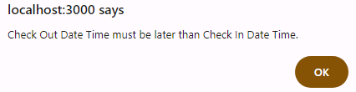
Database Captured |  |  | Passed  Data saved well  20240702  Success  TABLE: registration  aVolHours updated  TABLE: attendance  IDregistration  ChkInDTS  ChkOutDTS  volHours  aVolHours  To check all updated?
Programming Debug |  | completed | Passed  Submit button calculated the correct volHours.  TESTING PROGRESS  20240705 1313  REMARK  TABLE ATTENDANCE  Test error 1: First field not shown upon page load  Attendance.html  First Field did not show aVolHoursPrevious  The First Field  aVolHoursPrevious did not appear before clicking of Submit Button.  Test error 2:  After Submit Button the first field shown new aVolHours instead of avolHoursPrevious from registration table.  It does accumulate up from 2nd and 3rd submit which this result is at the wrong place, this correct result supposed to be shown at the 5th field “aVolHours” (last field instead of first field)  (this has to be retrieved from the registration table, column aVolHours of previous record, or show a 0 if there is no previous record)  test error 3:  click submit It also showed this dropdown alert message “Error recording attendance: Incorrect datetime value: '2024-07-04T17:22:00.000Z' for column 'chkInDTS' at row 1” so, I need to clear of first field figures before submit another time.  test error 4:  Calculation on accumulated volunteer hours not yet correct.  DATABASE  Table Registration  Accumulated Vol Hous not captured  Table Attendance  All five fileds not complete. | Completed

FORMS

User Registration – Volunteer Profile
Volunteer Login
Volunteer Attendance
Contact Us Form
Track Maintenance Report
Input on all fields
Click GPS offline functionality
Click Camera offline functionality
Click Offline Save Report to device
Click Online

Data Sync Submit Report

Automatically send email to DEC district officer when user selection of EMAIL DEC is Yes.

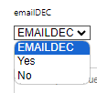

DATABASES

Test on all databases to check if it captures all information ideally.
Attached test data report.

DATA DICTIONARY

index.html  form id="registrationForm” | index.html  form id =”login” | contactus.html  form id="contactUs” | index.html  form id="casereport” | attendance.html  form id="attendance”
Table: registration  Columns:  IDregistration int AI PK  loginUserName varchar(20)  loginPassword varchar(8)  repeatPassord varchar(8)  fName varchar(20)  lname varchar(20)  eMail varchar(30)  hPhone varchar(20)  role varchar(10)  rLocality varchar(6)  fAddress varchar(90)  streetNumber varchar(3)  suburb varchar(10)  street varchar(30)  address1 varchar(30)  address2 varchar(30)  city varchar(5)  state varchar(20)  zipcode varchar(4)  volCat varchar(30)  tCert varchar(30)  background varchar(255)  aVolHours int  created_at datetime | Table: login  Columns:  IDlogin int AI PK  loginUserName varchar(45)  loginPassword varchar(45)  created_at datetime | Table: contactus  Columns:  IDcontactus int AI PK  name varchar(20)  email varchar(30)  subject varchar(45)  message varchar(255)  created_at datetime | Table: casereport  Columns:  IDcasereport int AI PK  idLogin int  dateTimePicker datetime  decDist varchar(30)  campsites varchar(20)  issueType varchar(20)  issuetypeoptions varchar(20)  problem varchar(3)  severity varchar(10)  frequency varchar(10)  emailDEC varchar(30)  issueDescription varchar(255)  latitude double  longitude double  photo blob  reporterName varchar(20)  reporterContact varchar(20)  created_at datetime | Table: attendance  Columns:  IDattendance int AI PK  IDregistration int  chkInDTS datetime  chkOutDTS datetime  volHours decimal(10,2)  created_at datetime

CODING PROGRAMMING

Validation:

Test on all programing ensuring it has all bugs cleared.
Remove causes of the errors if there is any.

F12 Console
Checking F12 on each and every thing on the website.



Test on SAVE BUTTON to ensure it save the report on the device properly.



Click button and check if data is being sent to the correct databases.
Test on Data Synchronization Button when online connection is available, and check if the data transfer from the device to the database.



Click button to confirm it sends email to the correct DEC district email address.
By building in all email address of all DEC district ahead, with the click on this button, an email attach with the report will be sent to that particular DEC District officer.

Define test criteria

The testing methods and related standards set forth in the table below for determining whether the App complies with the specification.

Thorough test is carried out in producing the best within the project’s time constraint.

Testable Conditions:
Acceptance Criteria serve as a basis for creating tests to validate that the user story has been implemented correctly.

Resources planning

We test it on Windows PC, Tablets, and android smart phone.
This development with cordova is able to extend to iOS version later on, if required.

Plan test environment

Testing by the web developer directly in enclosed environment, at the initial stage, so can review and fix any issue when discovered.

Auto-Testing Environment:
Tests (testRegistration.js) do not require server (server.js) to be running in production mode. They simulate conditions and check expected behaviors.

Auto-testing went through very quickly, a new browser pop up and in 2 second it went off, I could hardly see what’s happening. I implemented waits and pauses mechanism on the Selenium test script (testRegistration.js)

Explicit Wait:
Use Selenium's WebDriverWait to wait for elements to be located before interacting with them. This ensures that the script waits until the element is present and ready for interaction.

driver.wait method waits till the element with ID “registrationForm” is loaded on the page.

Use a longer timeout miliseconds (10,000).

const assert = require('assert');
let driver = await new Builder().forBrowser('chrome').build();
// Specify 'chrome' or ‘firefox’ here for testing on different browsers,
await driver.wait(until.elementLocated(By.id('registrationForm')), 10000);
//use a long miliseconds (10,000) or more.
Interactive Mode:
Manually click thru each step for further detail observation.

Schedule and estimation.

Starting with the testing on week 6, screen shot and do testing report at the same time while developing the app, in order to keep documentation accurate and up to date.

Remark on this table so able to come back to fix issue.

Test Data

Login
Hardcode for login:
Login User Name: Admin
Login Password: Asdf!234

Login Manual Validation Test

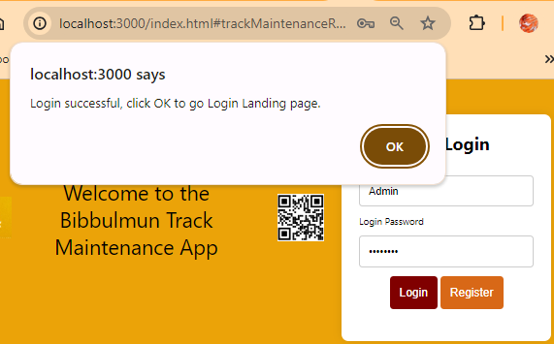

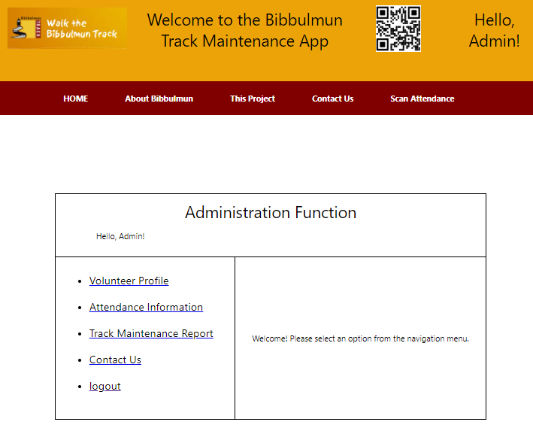

Registration
Hardcode for login:
Login User Name: Admin
Login Password: Asdf!234

Set up a set of validation rules in the registration form:
Registration.js

//(C) VALIDATION RULES
if (loginUserName === '') {
alert('Please enter a valid login username.');
return;
}

if (loginUserName === '' || loginPassword === '' || repeatPassword === '' || fName === '' || lname === '' || eMail === '' || hPhone === '' || streetNumber === '' || suburb === '' || street === '' || address1 === '' || city === '' || state === '' || zipcode === '' || role === '' || volCat === '') {
alert('Please fill out all required fields.');
return;
}

// Validate password strength (at least 8 characters, uppercase, lowercase, digit)
const passwordRegex = /^(?=.*[a-z])(?=.*[A-Z])(?=.*\d)[a-zA-Z\d]{8,}$/;
if (!passwordRegex.test(loginPassword)) {
alert('Password must be at least 8 characters long and contain at least one uppercase letter, one lowercase letter, and one digit.');
return;
}

// Ensure passwords match
if (registrationData.loginPassword !== registrationData.repeatPassword) {
alert('Passwords do not match!');
return;
}

// Validate email format
const emailRegex = /^[^\s@]+@[^\s@]+\.[^\s@]+$/;
if (!emailRegex.test(eMail)) {
alert('Please enter a valid email address.');
return;
}

// If all validations pass, submit the form
this.submit();

Test data: http://localhost:3000/html/registration.html

( A ) Manual Testing
( B ) Automatic Testing
CMD Install Chrome Driver
Check chrome version:
chrome://version/
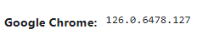

npm install selenium-webdriver

Dependencies:
Import necessary classes and methods from selenium-webdriver.
Selenium test script - testregistration.js
registerUser Function:
Simulates filling out the registration form fields and submitting the form.
Main runTest Function:
Sets up the WebDriver, calls registerUser, and handles cleanup after the test completes.
Execution: T
The script opens a browser (Chrome in this example), navigates to your registration page, fills out the form with dummy data, submits it, and checks for a success message.

TESTFORM: Test Data Registration

FIELD | Test data 01 | Test data 02 | Test data 03 |  | REMARKS
Login Username | admin | uc | lec
Login Password | Asdf!234 | Asdf!001 | Asdf!001
Repeat Password | Asdf!234 | Asdf!001 | Asdf!001
First Name | Terry | Peter | Poh Kok
Last Name (Surname) | Koziniec | Cole | Loo
Email Address | Terry@a.com | peter@a.com | loo@a.com
Hand Phone  Number | 90000001 | 90000002 | 90000003
Role Dropdown | System Admin | UC | Lecturer
Residential Location Dropdown | null | null | null
Full Address | null | null | null |  | Standby for user with overseas address different format
Street number | 1 | 2 | 3 |  | Loca address street number
Suburb dropdown | Subiaco | Fermantle | Cottesloe
Street dropdown | Hay Street | High Street  20240704 testing  High street did not appear. | Napier Street |  | Perth streets
Address line 1 | null | null | null
Address line 2 | null | null | null
Zip/Postal Code | 1111 | 0002 | 0003
Volunteer profile  Roles Support Categories dropdown | Office Maintenance Admin | Office General | Office Marketing and communications
Certificates Check Box | St John  IT  Sales | Office Admin  Office Mktg  Office Comm | IT programming  Office Communication
Background  description | Client | Client Liasson | Project Manager
Register button | CLICK   | CLICK | CLICK  20240706 0057  Error Fetching Data / Registration failed: - line 152 Registration successful - line 291
Send a confirmation email to the user

Return to index.html after registration
Result

Password validation failed | passed  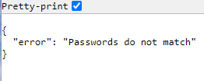 | passed | passed
Missed field check | passed  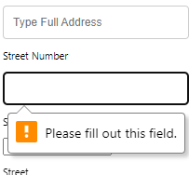 | passed | passed  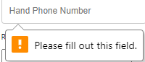
Validation to prevent duplicate registration

Result captured in the MySQL databases  (see attached) | passed | passed | passed

Registration Manual Validation Test

When password does not match repeat password, it shows an error message and stop from proceeding.

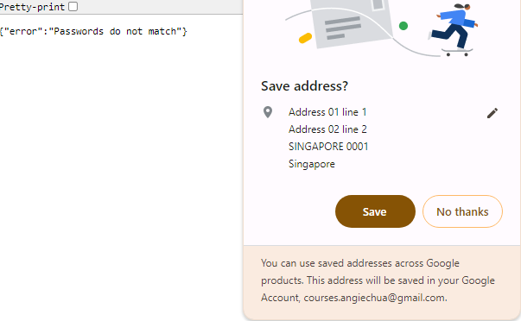

Registration input captured in the MySQL databases

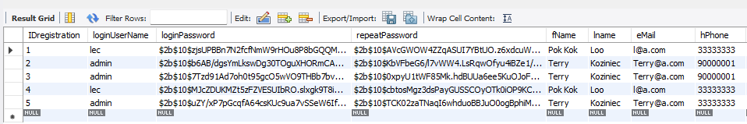

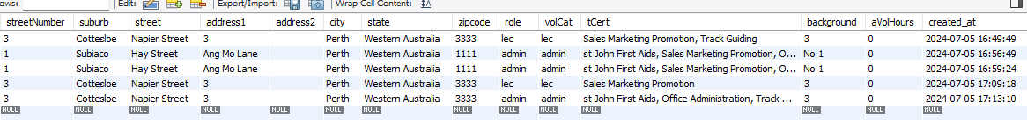

Returned with hashed password

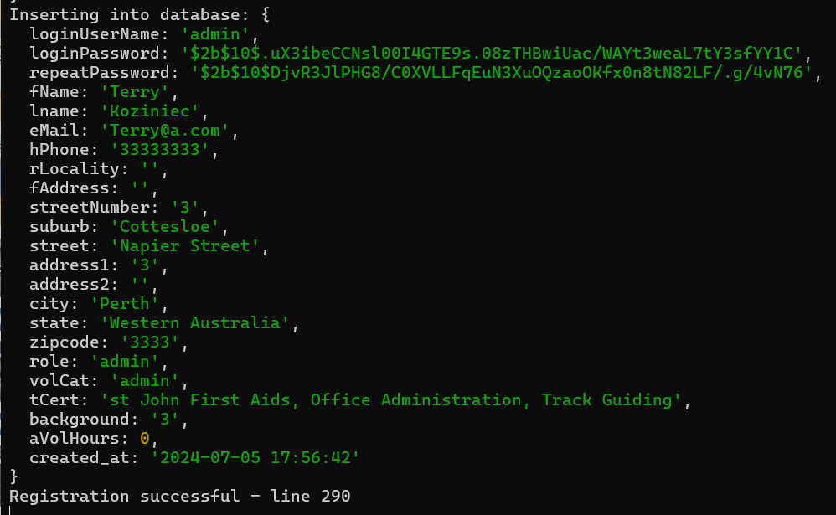

Campsite Report

Based on the Client Terry’s email, we designed a “dynamic drop down form” for the user to select “Campsite” automatically based on DEC district.

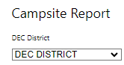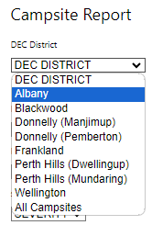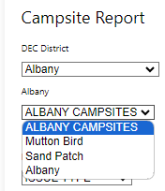

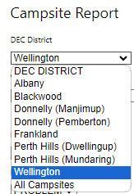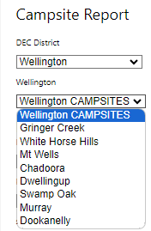

when DEC District Albany is selected, only campsites belonged to Albany district will appear for further selection.

when DEC District Wellington is selected, only campsites belonged to Wellington district will appear for further selection.

This arrangement takes in consideration with the needs to “contact or email case report” to the relevant DEC district authority for important information.

Tentatively, the sequence of the campsites is designed according to the direction walking direction from the start point as given in the Terry’s email until further notice.

However, we have also provided one more, “all campsites”, with a long list of all Bibbulmun track campsites arranged in the alphabetical order for the convenience of quick search, or just in case the user does not know which DEC district it belonged to.

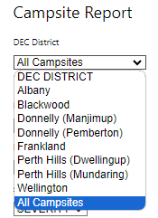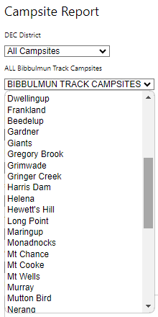

Testing Result

Testing On:

The Linking from Baack-end to Front-end

- CLIENT AND SERVER

- Backend Server: Server and routing

As the server.js getting very long, we tried to break them into modular using routers.

This is the connection between the database, local storage, javascript instructions, and html, css files.

The server set GET POST to pick up the contents input from html, FETCHED by JavaScript’s located and www/js folder. E.g., the js/file.js., and store in the database, or local storage.

- Frontend Client-Side: Js/file.js

The js folder keeping all the javascripts which are the instruction / programming to monitor the .html behaviours, and connection between the server.js and the html, as well as the database.

Instruction includes collect values from the user input on the various forms.

- Frontend Client-Side: index.html, html/file.html css/file.css
keeping all the web pages and front end presentations, forms for users’ input, basically,
track maintenance report (case Report form),
Registration form
Login form
Attendance form
Contact us form
etc.

- External Link: linking to “Walk the Bibbulmun Track” website.

The navigator linkage to the BTF existing current website, by clicking the 2nd tab on the navigator,

The FTP can also add in a login/registration link and link their site to this newly developed app, by simply adding the following code to their index.html page:

<div id = ”connectToBTF”
<a href="replaceThisLink "> Login/Registration </a>
</div>

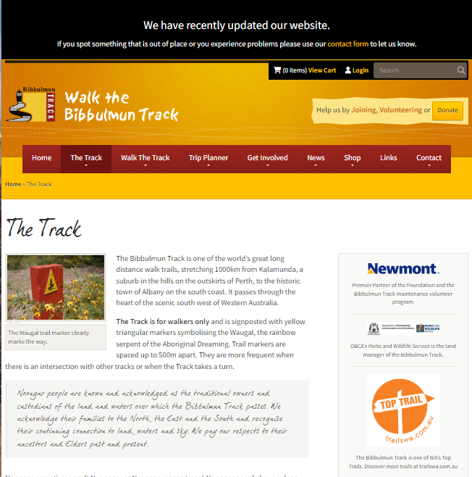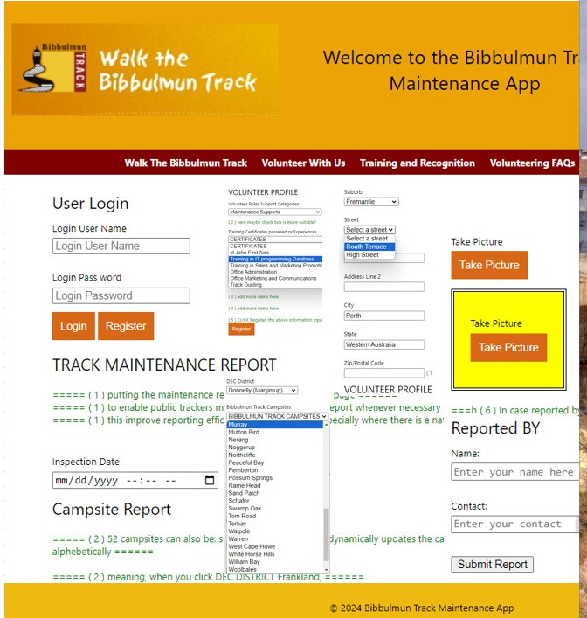

UI input, MySQL Databases capture, correctness

Programming Debug

Web and mobile design using Node.js and cordova.
Database using MySQL with Express.

Testing On Accumulated Volunteer Hours - Completed

Testing on capturing the attendance and calculation of Accumulated Volunteer Hours

Test Result Outcome: Input validation - success

Test on the validation ChkoutDTS (Check out Date Time Stamp) must be later than the ChkInDTS (Check in Date Time Stamp).

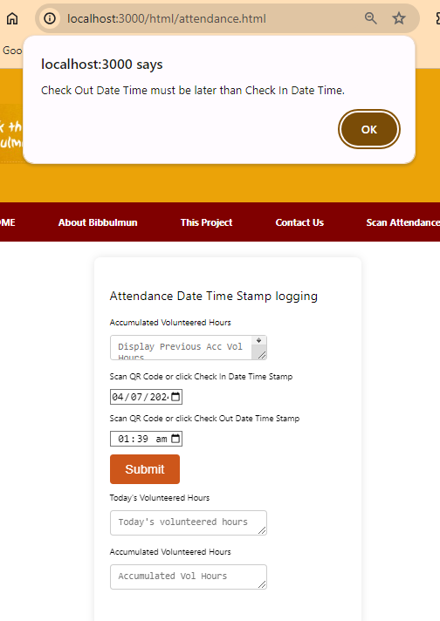

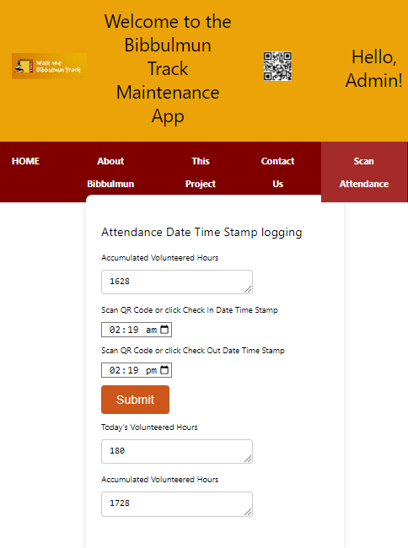

Test Result Outcome: input, compute and save in DB correctly - success

Test Date: 20240704 0058
Accumulation of the Volunteers Hours succeeded.

Testing Method: Using MySQL WorkBench

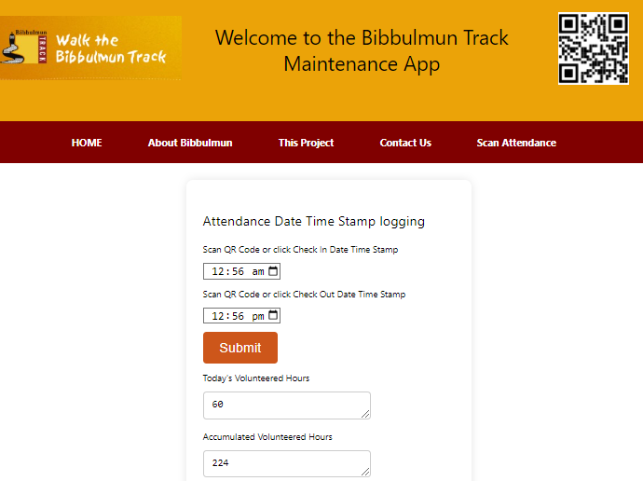

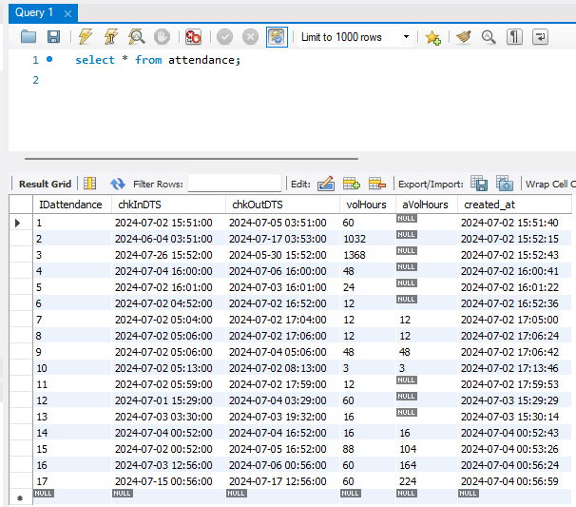

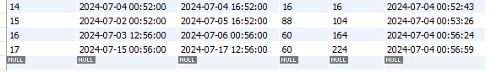

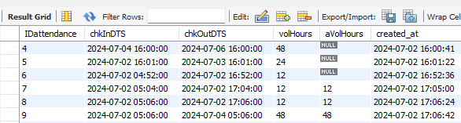

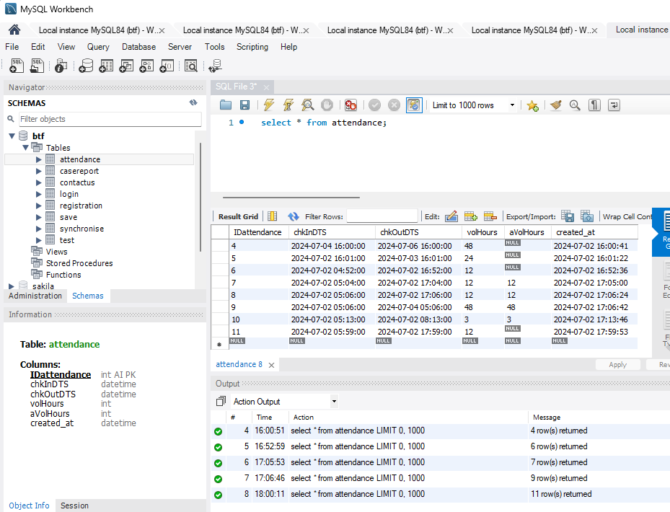

Testing Method: RUN CMD as administrator Using system32

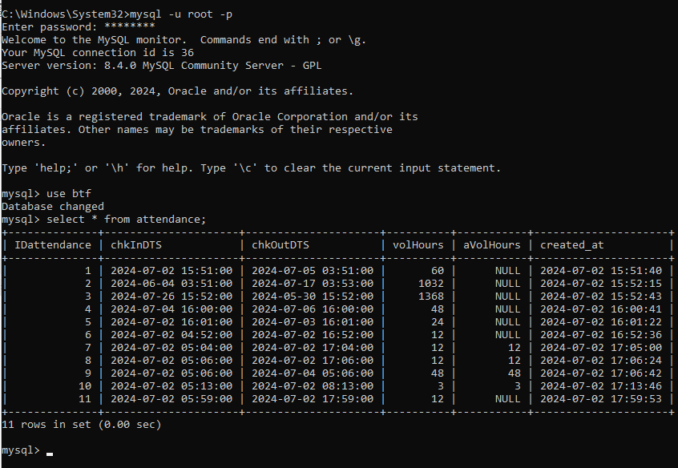

Testing On Form Contact Us - completed

Testing MySQL databases on capturing the contact us form sent by users.

Test Result Outcome: success

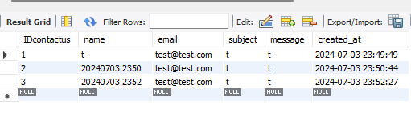

Test Date: 20240630 0805
All columns captured correctly; all input kept in MySQL database succeeded.

Testing Method: Using MySQL WorkBench

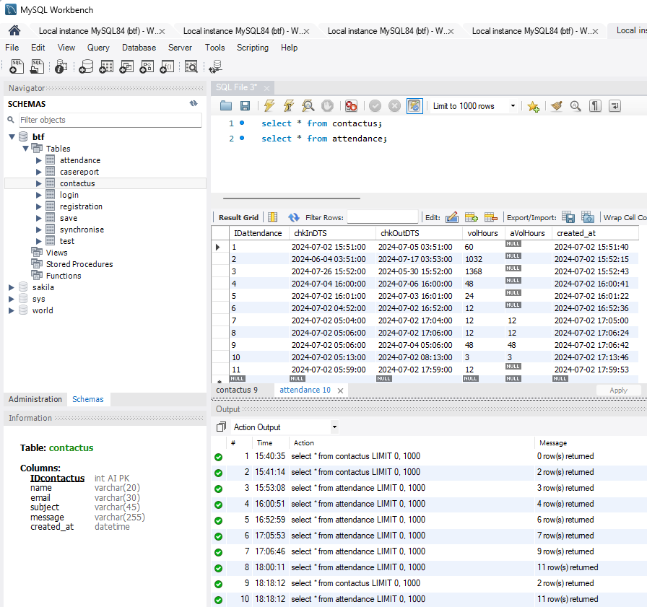

Testing Method: RUN CMD as administrator Using system32

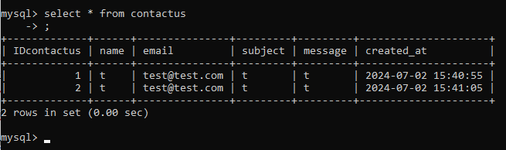

Conclusion

The purpose of this testing, aims to ensure the developed web and mobile app meets all client’s requirements and is free of defects.

We adopt water-fall methodology in performing the test, stage by stage along with the development of the app right at the beginning. This helps in fixing bugs at the early stage when it’s not too difficult.

Well-organized systematic test plan was carried out along the development of the website, right from the beginning of UI design, form testing, and linkage between frontend UI html and backend server and databases.

Test reports are prepared gradually together with the development of the app. And it serves as notes at hand as well during the development.

References
APA. (2022, Sept 08). APA 7th Edition Sample. Retrieved from APA: https://apastyle.apa.org/instructional-aids/reference-examples.pdf
Institute, P. M. (2024, 05 08). PMBOK® Guide. Retrieved from pmi.org.pmbok: https://www.pmi.org/pmbok-guide-standards/foundational/pmbok
Style, A. (2020). Publication Manual of the American Psychological Association, Seventh Edition (2020). Retrieved from APA Style American Psychological Association: https://apastyle.apa.org/products/publication-manual-7th-edition

Appendices

